Exp. No: 2
Determination and plotting of Electric field and Electric flux density in sphere full of charges with varying radius.
Aim:
To write program for electric field and electric flux density in sphere using
SCILAB.

Software required:
- SCILAB version 6.0.1

Program:
clc; clear;
q=input('Enter the value of q='); r=input('Enter the value of r=');

efcilon=8.854*10^-12; pi=3.14
E=q/4*pi*efcilon*r^2; disp("The electric field is", [E]); D=E*efcilon;
disp("The flux density is", [D]);
x = linspace(0, 10, 50);
y = E * exp(-0.1 * x);
z = D * exp(-0.1 * x);

figure(); subplot(2, 2, 1);
plot2d3(x,y);
xlabel("R");
ylabel("Electric field intensity"); title('Electric field intensity'); subplot(2, 2, 2);
plot2d3(x,z);
xlabel("A");
ylabel("Electric flux intensity"); title('Electric flux intensity');

Output:-

Enter the value of q=5*10^-6 Enter the value of r=5
"The electric field is" 1.79D-7
"The flux density is" 1.591D-4

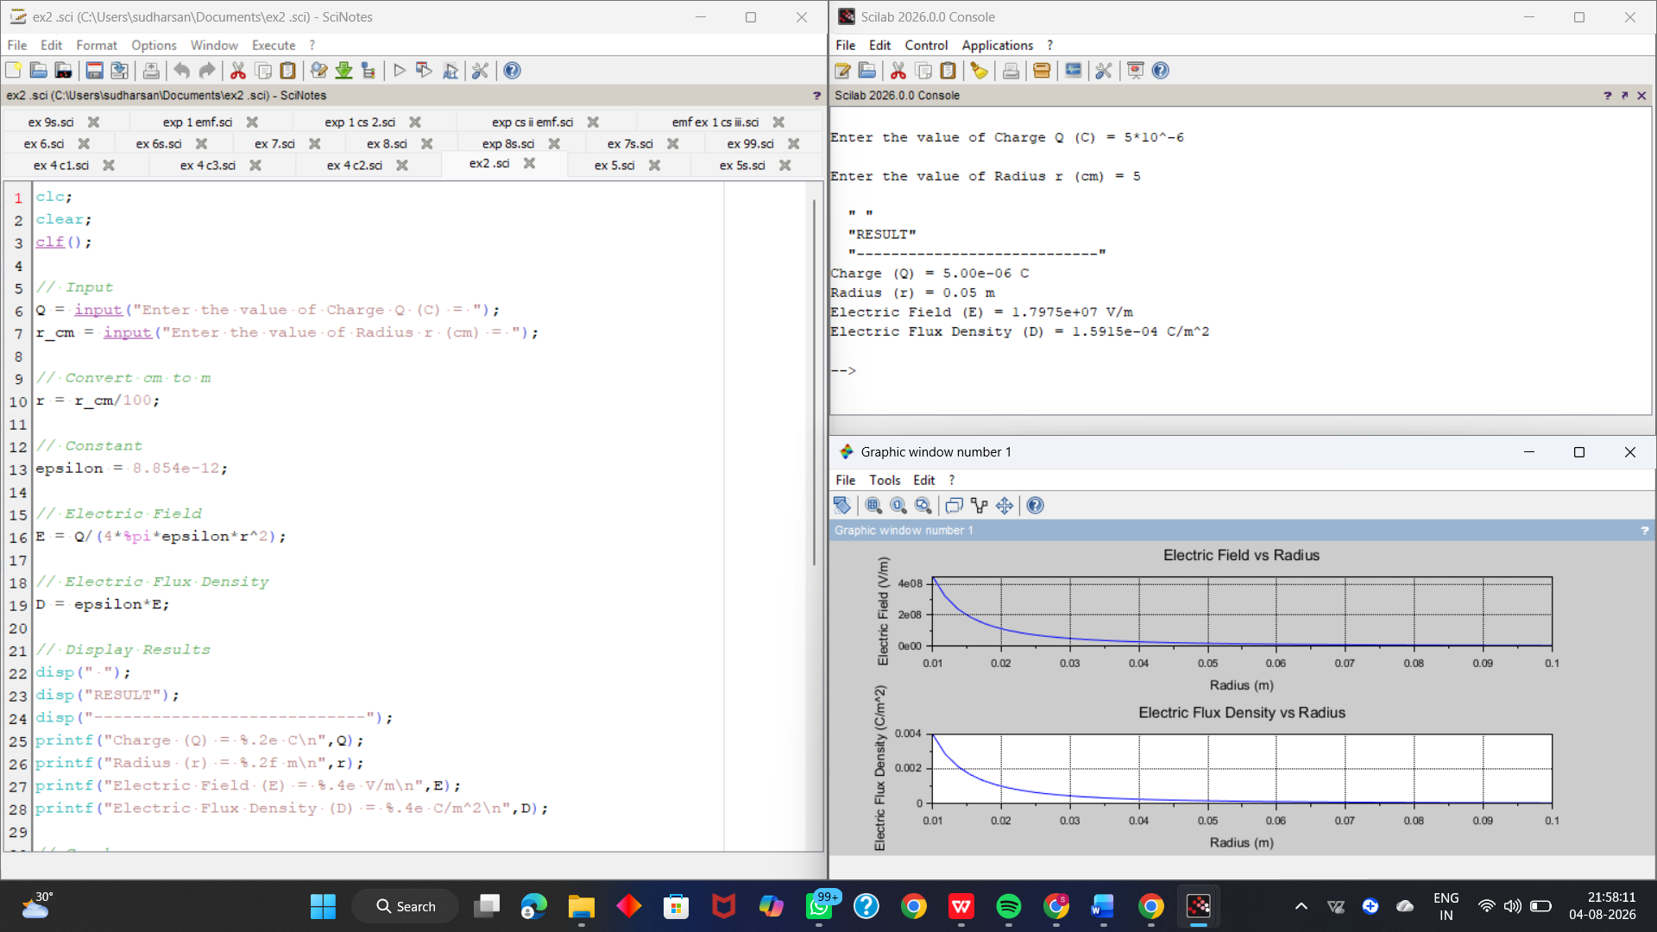

Calculation:
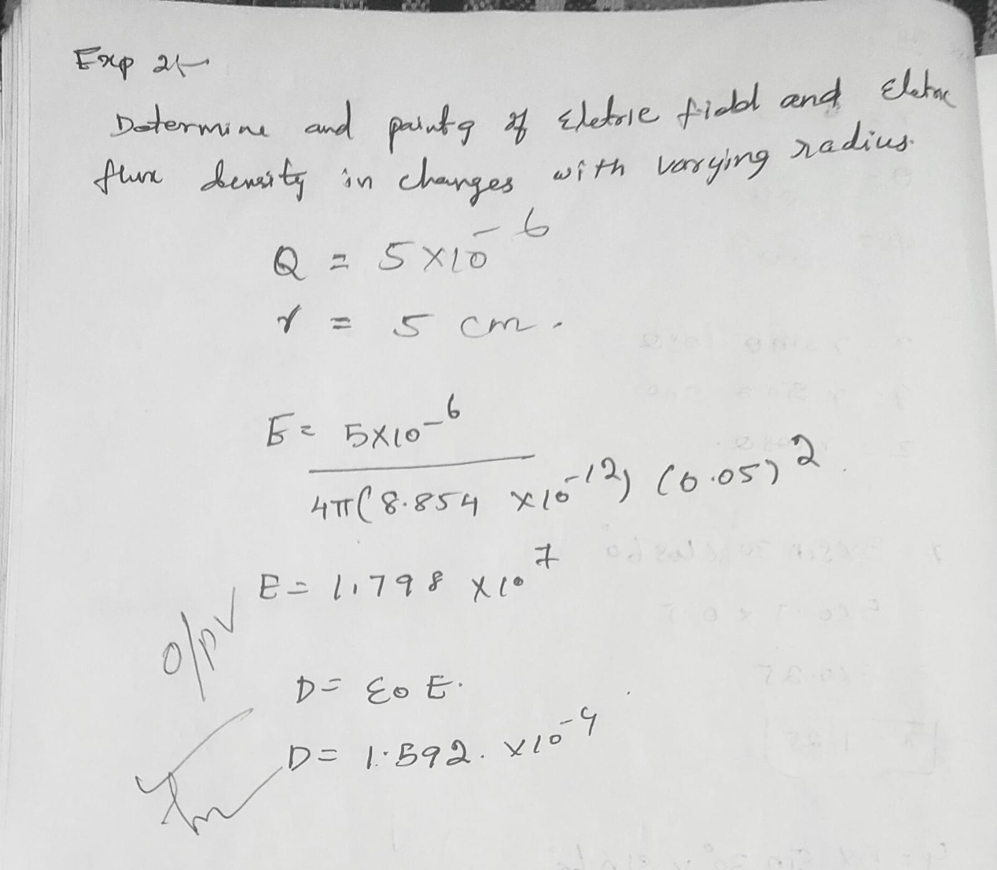

Case 1:
Derive and plot the electric field (E) and electric flux density (D) inside a uniformly charged sphere with charge density ρ0. What are the values of E and D at the center and at the surface of the sphere?

Code:
rho0 = 1e-6; // Uniform charge density (C/m^3) epsilon = 8.854e-12; // Permittivity of free space (F/m) R = 1; // Radius of the sphere (m)
n = 100; // Number of steps for plotting
r = linspace(0, R, n); // Radial distances

// Initialize arrays for D and E
D = zeros(1, n);
E = zeros(1, n);
// Calculate D and E
for i = 1:n
ri = r(i); // Current radius
// Enclosed charge Q_enclosed = rho0 * (4/3) * pi * r^3
Q_enclosed = rho0 * (4/3) * %pi * ri^3;

// Electric Flux Density D
if ri ~= 0 then
D(i) = Q_enclosed / (4 * %pi * ri^2); else
D(i) = 0; // Avoid division by zero end

// Electric Field E = D / epsilon
E(i) = D(i) / epsilon; end

// Plotting
subplot(1, 2, 1);
plot(r, D, "r");
xlabel("Radius (m)");
ylabel("Electric Flux Density (D) [C/m^2]"); title("Uniform Density: D vs. Radius");
subplot(1, 2, 2);
plot(r, E, "b");
xlabel("Radius (m)"); ylabel("Electric Field (E) [V/m]");
title("Uniform Density: E vs. Radius");

Output:

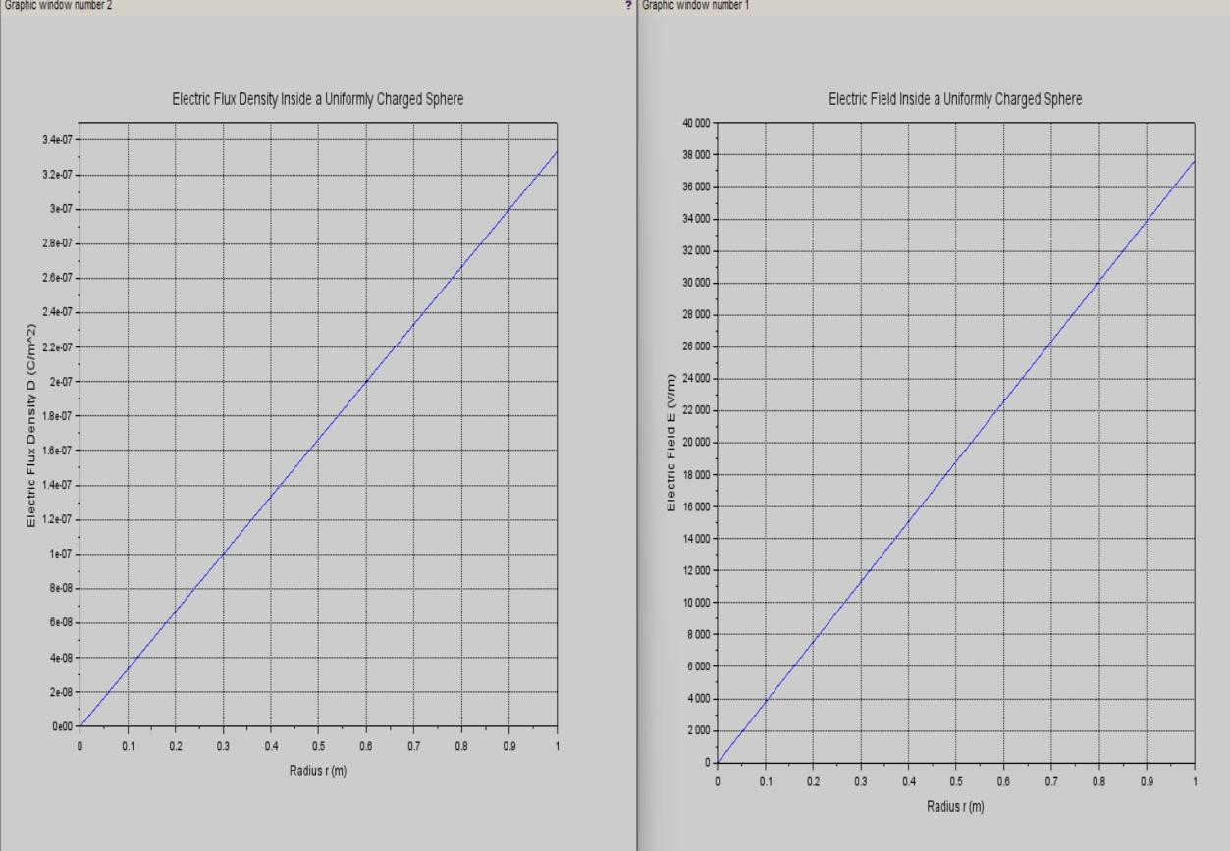

Case 2:
For a sphere with a linearly increasing charge density ρv=ρ0r.derive the expressions for the electric field (E) and electric flux density (D). Plot their variations inside the sphere and analyze the trends.

Code:
// Parameters
rho0 = 1e-6; // Coefficient for linearly increasing charge density (C/m^4)
epsilon = 8.854e-12; // Permittivity of free space (F/m)
R = 1; // Radius of the sphere (m)
n = 100; // Number of steps for plotting
r = linspace(0, R, n); // Radial distances
// Initialize arrays for D and E
D = zeros(1, n);
E = zeros(1, n);
// Calculate D and E
for i = 1:n
ri = r(i); // Current radius
// Enclosed charge Q_enclosed = rho0 * pi * r^4
Q_enclosed = rho0 * %pi * ri^4;
// Electric Flux Density D
if ri ~= 0 then
D(i) = Q_enclosed / (4 * %pi * ri^2); else
D(i) = 0; // Avoid division by zero end

// Electric Field E = D / epsilon
E(i) = D(i) / epsilon;

end
// Plotting
subplot(1, 2, 1);
plot(r, D, "r");
xlabel("Radius (m)");
ylabel("Electric Flux Density (D) [C/m^2]"); title("Linear Density: D vs. Radius");

subplot(1, 2, 2);
plot(r, E, "b");
xlabel("Radius (m)"); ylabel("Electric Field (E) [V/m]"); title("Linear Density: E vs. Radius");

Output:

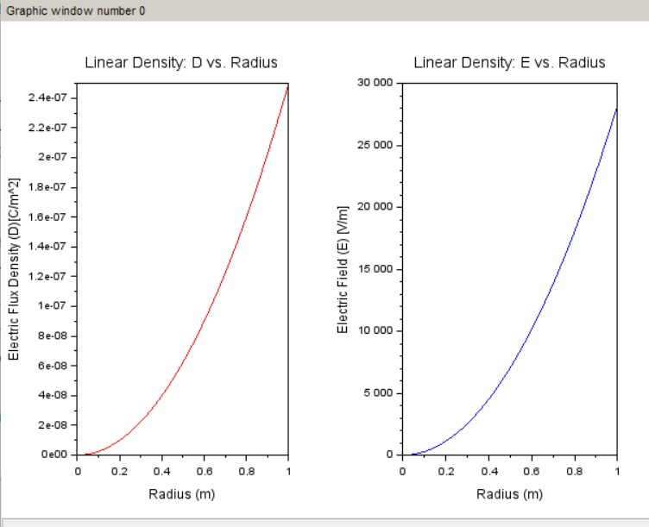

Case 3:
A sphere of radius R=2 m has a uniform charge density ρ=3×10^−6 C/m^3\

- Calculate and plot the electric flux density D(r) and electric field E(r) as a function of radial distance r, ranging from 0 to 4 meters.
- Discuss the behaviour of the electric field inside and outside the sphere.

Code:
rho0 = 3e-6; // Uniform charge density (C/m^3) epsilon = 8.854e-12; // Permittivity of free space (F/m) R = 2; // Radius of the sphere (m)
n = 200; // Number of steps for plotting
r = linspace(0, 4, n); // Radial distances from 0 to 4 meters

// Initialize arrays for D and E
D = zeros(1, n);
E = zeros(1, n);
// Calculate the total charge enclosed in the sphere
Q_total = rho0 * (4 * %pi * R^3 / 3);
// Calculate D and E
for i = 1:n
ri = r(i); // Current radius

// Enclosed charge for r < R (inside the sphere)
if ri < R then
Q_enclosed = rho0 * (4 * %pi * ri^3 / 3);
// Enclosed charge for r >= R (outside the sphere)
else
Q_enclosed = Q_total; end
// Electric Flux Density D
D(i) = Q_enclosed / (4 * %pi * ri^2);

// Electric Field E = D / epsilon
E(i) = D(i) / epsilon; end
// Plotting
subplot(1, 2, 1);
plot(r, D, "r");
xlabel("Radius (m)");
ylabel("Electric Flux Density (D) [C/m^2]"); title("Uniform Charge Density: D vs. Radius"); subplot(1, 2, 2);
plot(r, E, "b");
xlabel("Radius (m)"); ylabel("Electric Field (E) [V/m]");
title("Uniform Charge Density: E vs. Radius");

Output:

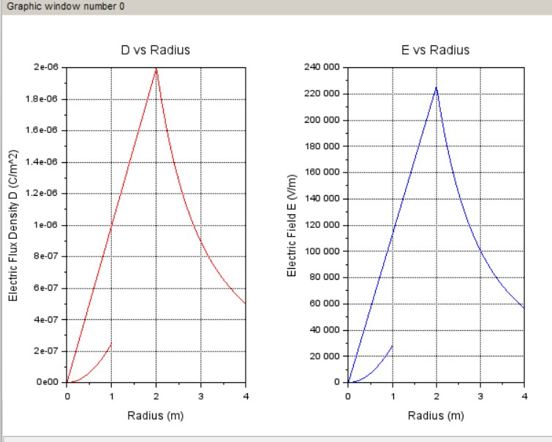

Result :
Thus the program was verified for electric field and electric flux density in sphere using SCILAB was successfully.

